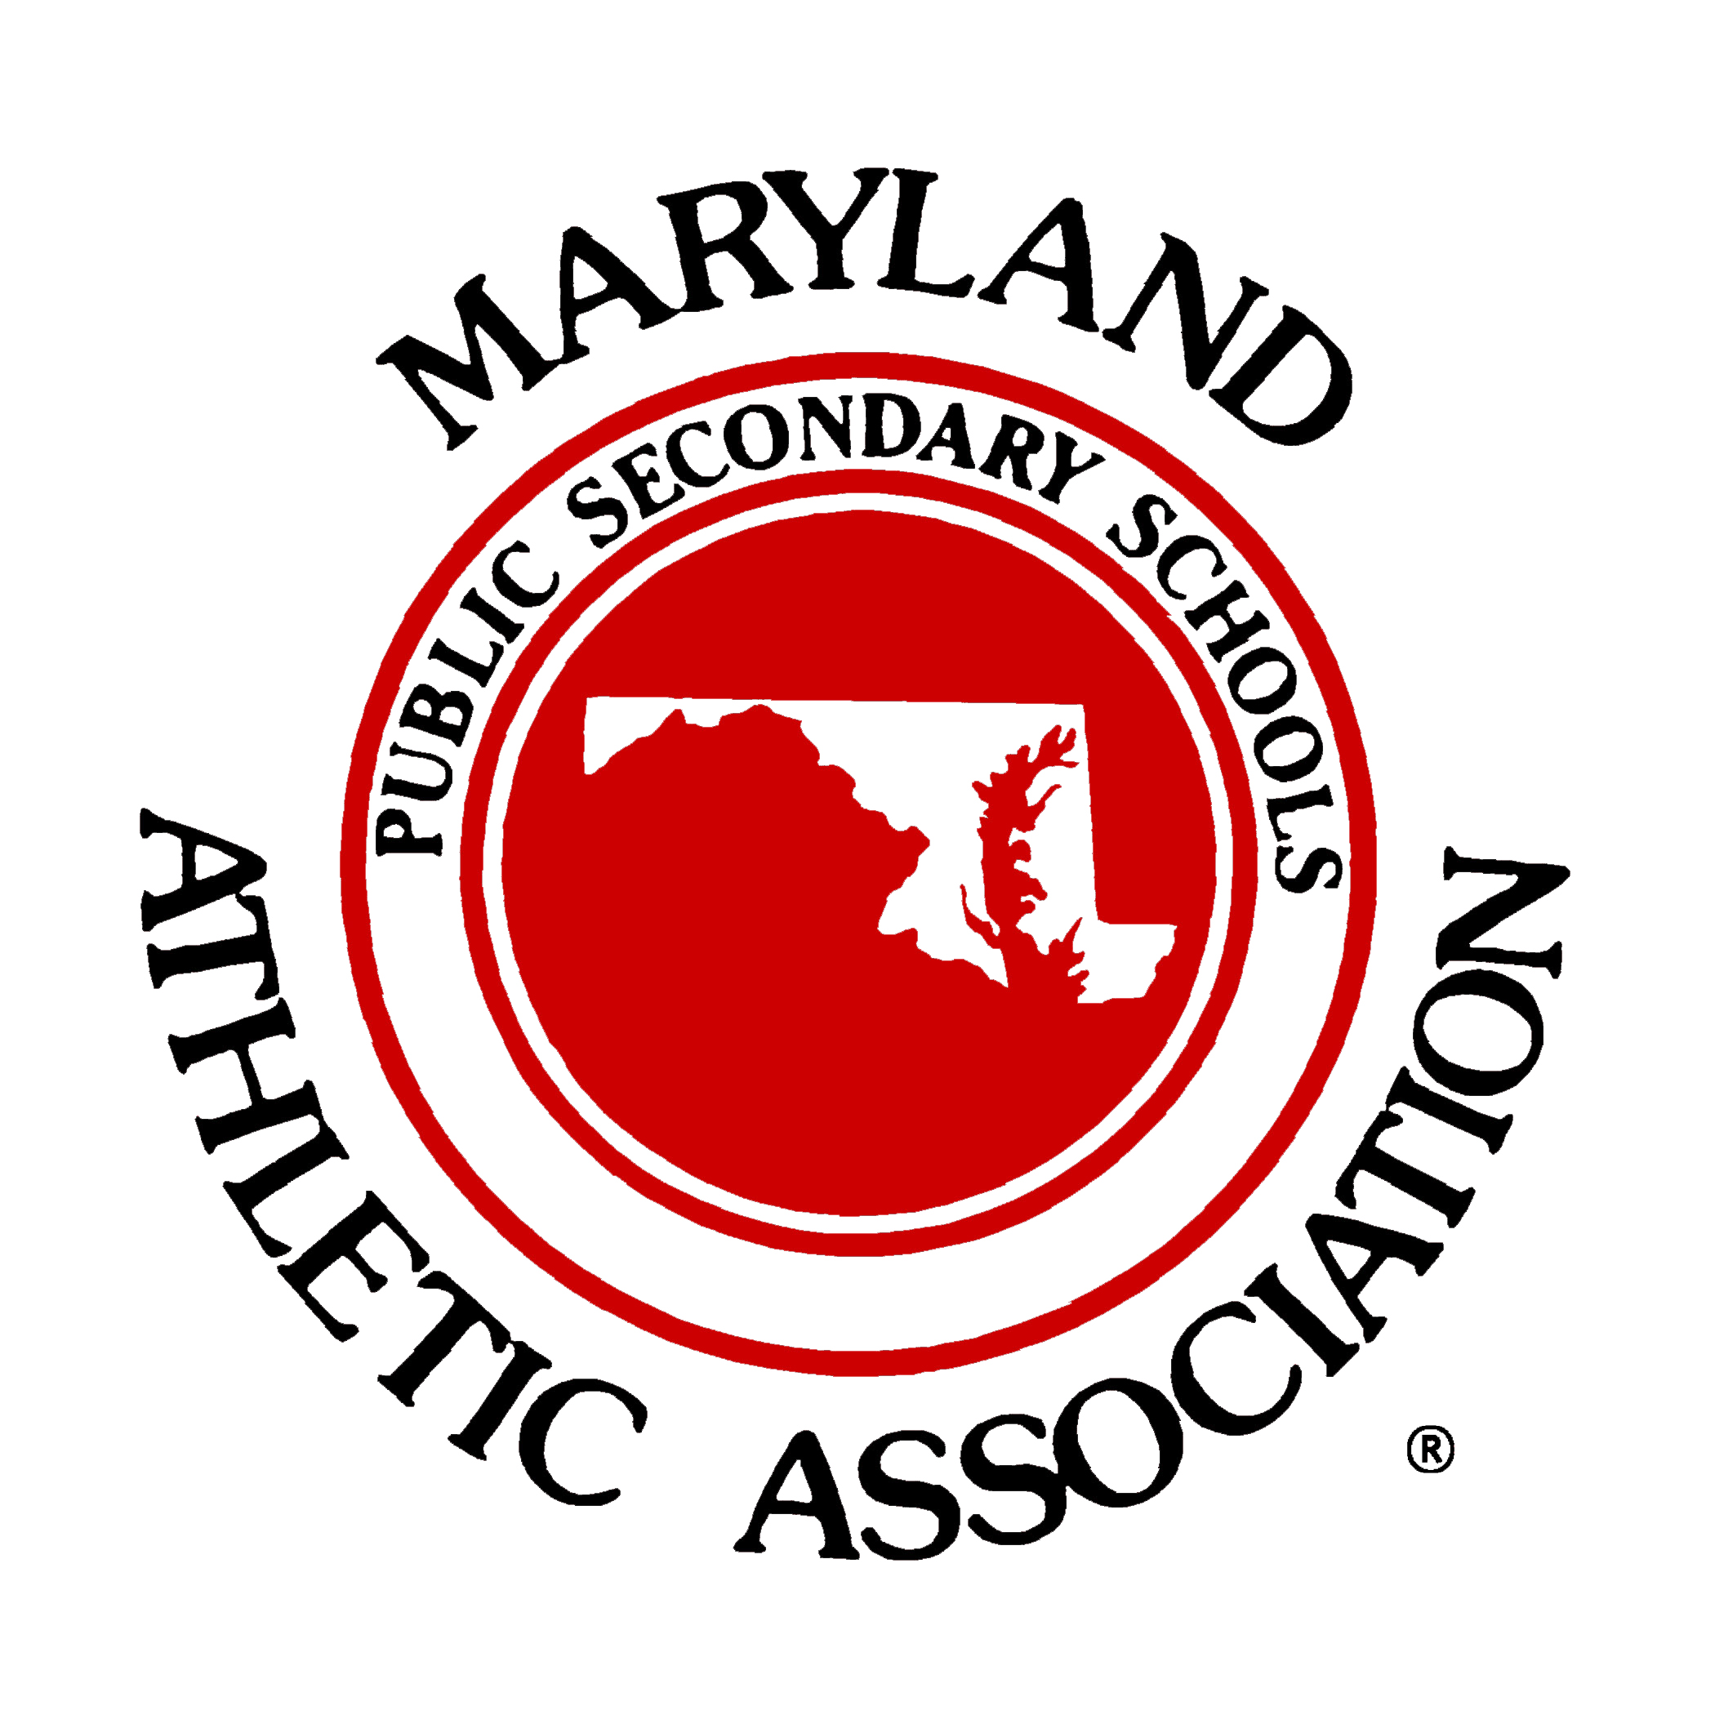

PA Announcement
(General reminder during contest)

In recent years much has been learned regarding the seriousness
of concussion and the precautions needed prior to returning to play.

This week has been designated “Concussion Awareness Week” by
The Maryland Public Secondary Schools Athletic Association.

Parents, students and coaches are strongly encouraged to learn
concussion signs and symptoms and follow return to play protocol.

For more information, simply logon to www.mpssaa.org.
Remember When in doubt-Sit them out.

